**Read Me**

How to run the project?

1. Download zip file of the project from git hub link:

<https://github.com/Manish-K-Arora/Phase4ProjectOnlinetestapplication>

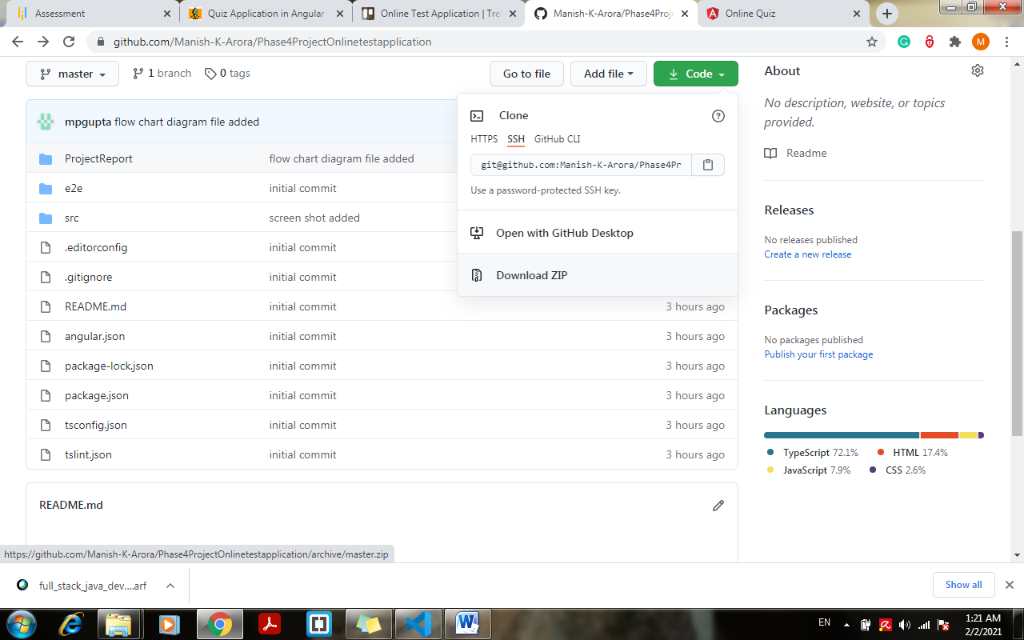

1. Extract the project
2. Open the Visual Code Studio > File > Select the folder Path where the project extracted.
3. Run command : “npm install” in order to install all the node_modules and required package.
4. Run the command: “ng serve”
5. Application will take some time to compile and run
6. Open your browser after compiled successfully and enter <http://localhost:4200/>
7. Quiz will start on browser.
8. Expanded View of the src folder:

